Chapter 11, Solution 25.

Find the rms value of the signal shown in Fig. 11.56.

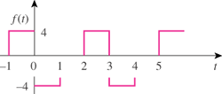

Figure 11.56
For Prob. 11.25.

Solution

f_{rms} = 3.266

